Data.php

<?php  
*//Loading classes  
spl_autoload_register*('autoload');  
function autoload($sClassname): void  
{  
 require_once($sClassname . ".php");  
}  
*//Load pre-defined users and add to UserList*$user = new User("admin1", "abcdefgh", "email", 1); *//ADMIN*$user1 = new User("PhpLover1", "abcdefgh", "email"); *//USER*$user2 = new User("jdoe", "abcdefgh", "email"); *//USER*$userList = new UserList(); *//VERWALTUNG ALLER USER*$userList->addUser($user);  
$userList->addUser($user1);  
$userList->addUser($user2);  
  
*//An admin is logged in in the recent TodoList*$toDoList = new TodoList($user);  
  
*//Creating various tasks*$entry = new ToDoListItem("e1", new DateTime("2021-02-01"), $user2->userId, "Hausarbeit", new DateTime("2021-02-01"));  
$entry1 = new ToDoListItem("e2", new DateTime("2021-04-05"), $user1->userId, "Hausübung machen", new DateTime("2021-04-02"), "Dringend die PHP Hausübung abgeben :D");  
$entry2 = new ToDoListItem("e3", new DateTime("2021-03-06"), $user1->userId, "Yoga", new DateTime("2021-03-02"));  
$entry3 = new ToDoListItem("e4", new DateTime("2021-08-05"), $user2->userId, "Prokrastinieren", new DateTime("2021-03-02"), "Ich bin eine Notiz, hallo!");  
  
*//Add tasks to TodoList*$toDoList->addEntry($entry);  
$toDoList->addEntry($entry1);  
$toDoList->addEntry($entry2);  
$toDoList->addEntry($entry3);  
?>

Index.php

<?php  
require_once "data.php";  
*session_start*(); *//Zugriff auf Session Array*?>  
  
<!doctype html>  
<html lang="en">  
<head>  
 <meta charset="UTF-8">  
 <title>ToDoList</title>  
 <link rel="stylesheet" type="text/css" href="style.css"/>  
 <link rel="stylesheet" href="https://stackpath.bootstrapcdn.com/bootstrap/4.4.1/css/bootstrap.min.css" integrity="sha384-Vkoo8x4CGsO3+Hhxv8T/Q5PaXtkKtu6ug5TOeNV6gBiFeWPGFN9MuhOf23Q9Ifjh" crossorigin="anonymous">  
</head>  
<body>  
  
<?php  
global $toDoList; *//TodoList of data.php*global $userList; *//UserList of data.php  
//Vordefinierte Todoliste soll nur beim ersten Mal eingespielt werden  
//Ermöglicht Aktualisieren der Todoliste  
//und der Userliste mittels Session-Variable  
  
//Pre-defined TodoList should only be loaded at the first time  
//So the Todolist can be updated frequently with new tasks  
//and wont be overwritten by the old TodoList*if(!isset($_SESSION["todolist"])){  
 $_SESSION["todolist"] = $toDoList;  
}  
  
*//Pre-defined UserList should only be loaded at the first time  
//So the UserList can be updated frequently with new users  
//and wont be overwritten by the old UserList*else if(!isset($_SESSION["userlist"])){  
 $_SESSION["userlist"] = $userList;  
}  
*//Login and Registration Process incl. Error-Handling*$errors = [];  
if(!isset($_SESSION["user"])){  
  
 *//case user is not logged in* if(isset($_REQUEST["action"]) && $_REQUEST["action"] == "login"){  
  
 *//case user wants to log in* if(isset($_REQUEST["username"])  
 && isset($_REQUEST["password"])  
 && $_REQUEST["username"] != ""  
 && $_REQUEST["password"] != ""  
 && checkLogin($_REQUEST["username"], $_REQUEST["password"])){

*//case user data is correct* $_SESSION["user"] = $_REQUEST["username"];  
 showData();  
 showTaskForm();  
 showLogoutForm();  
 }  
 else{  
 *//case user data is incorrect* echo("<div class='notify red'>Login data incorrect!</div>");  
 showLoginForm();  
 showRegistrationForm();  
 }  
 }  
 else if(isset($_REQUEST["action"]) && $_REQUEST["action"] == "register"){  
  
 *//case user wants to register* if(checkRegistration()){  
  
 *//data correct* register();  
 }  
 else{  
 *//data incorrect* echo("<div class='notify red'>Registration data not correct!</div>");  
 }  
 showLoginForm();  
 showRegistrationForm();  
 }  
 else{  
 *//case user wants to view page* showLoginForm();  
 showRegistrationForm();  
 }  
}  
*//case user is logged in*else{  
 *//case user creates new task* if(isset($_REQUEST["action"]) && $_REQUEST["action"] == "addTasks"){  
 if(checkAddEntry())  
 actualizeData();  
 showData();  
 showTaskForm();  
 showLogoutForm();  
 }  
 *//case user wants to logout* else if(isset($_REQUEST["action"]) && $_REQUEST["action"] == "logout"){  
 unset($_SESSION["user"]);  
 showLoginForm();  
 showRegistrationForm();  
 }  
 *//case user wants to view page* else{  
 showData();  
 showTaskForm();  
 showLogoutForm();  
 }  
}

*//register()  
//This function allows a new user to register by entering all  
//data needed. If the user wants to register with a already  
//existing username, a error message shows up.*function register(){  
 try {  
 $newUser = new User($_REQUEST["usernamereg"], $_REQUEST["password1"], $_REQUEST["email"]);  
 $_SESSION["userlist"]->addUser($newUser);  
 echo("<div class='notify green'>Registration successful!</div>");  
 } catch (Exception $e){  
 echo("<div class='notify red'>".$e->getMessage()."</div>");  
 }  
}  
  
*//actualizeData()  
//The TodoList will be updated by adding a new TodoListItem.*function actualizeData(){  
 $entry = new TodoListItem("e".*rand*(), new DateTime("now"), $_SESSION["user"], $_REQUEST["addTitle"], new DateTime("now"), $_REQUEST["addNote"]);  
 $_SESSION["todolist"]->addEntry($entry);  
}  
  
*//checkAddEntry()  
//Checks the input fields of the form to add new tasks*function checkAddEntry():bool{  
 global $errors;  
 if(!isset($_REQUEST["addTitle"]) || *strlen*($_REQUEST["addTitle"]) < 6)  
 $errors["addTitle"] = "<i>Title must be at least 6 characters long!</i>";  
  
 if(*count*($errors) > 0)  
 return false;  
 return true;  
}  
  
*//checkLogin()  
//Checks the input fields of the login form by comparing it with the saved data of the userList.*

*//Only if username and password are correct, the user can login.*function checkLogin(string $username, string $password):bool{  
 return($username == $_SESSION["userlist"]->users[$username]->userId && $password == $_SESSION["userlist"]->users[$username]->password);  
}  
  
*//checkRegistration()  
//Checks if various rules of the input fields of the registration form  
//are followed. Otherwise the errors will be saved.*function checkRegistration():bool{  
 global $errors;  
 *//username* if(!isset($_REQUEST["usernamereg"]) || *strlen*($_REQUEST["usernamereg"]) < 6)  
 $errors["usernamereg"] = "<br><i>Username must be at least 6 characters long</i>";

*//password* if(!isset($_REQUEST["password1"]) ||  
 !isset($_REQUEST["password2"]) ||  
 $_REQUEST["password1"] != $_REQUEST["password2"] ||  
 *strlen*($_REQUEST["password1"]) < 8)  
 $errors["password1"] = "<br><i>Password must be at least 8 characters long and must match</i>";  
  
 *//email* if(!isset($_REQUEST["email"]) || *filter_var*($_REQUEST["email"], *FILTER_VALIDATE_EMAIL*) === false)  
 $errors["email"] = "<br><i>Must be a valid email address</i>";  
  
 if(*count*($errors) > 0)  
 return false;  
 return true;  
}  
  
*//showData()  
//This function prints the (updated) TodoList. Only tasks of the  
//user who is logged in will be shown, all other tasks wont be  
//visible for this user.*function showData(){  
 $user = $_SESSION["userlist"]->users[$_SESSION["user"]];  
 $_SESSION["todolist"]->loginUser = $user;  
 echo($_SESSION["todolist"]);  
}  
  
*//showTaskForm()  
//Output of the TaskForm - if errors occur, the incorrect fields  
//will be highlighted and the error will be described*function showTaskForm(){  
 global $errors;  
 $title = "";  
  
 if(isset($_REQUEST["addTitle"]) && *count*($errors) > 0){  
 $title = $_REQUEST["addTitle"];  
 }  
 ?>  
  
 <div class="form-style-5">  
 <form action="<?php echo($_SERVER['PHP_SELF']);?>" method="post">  
 <fieldset>  
 <legend><span class="number">+</span>Eintrag hinzufügen</legend>  
 <?php  
 if(isset($errors["addTitle"])){  
 echo('<input type="text" name="addTitle" id="addTitle" placeholder="Titel*" class="error" value="'.$title.'">');  
 echo($errors["addTitle"]);  
 }  
 else echo('<input type="text" name="addTitle" id="addTitle" placeholder="Titel*" value="'.$title.'">');  
  
 if(isset($_REQUEST["addNote"]) && *count*($errors) > 0){  
 $desc = $_REQUEST["addNote"];  
 echo('<textarea name="addNote" id="addNote">'.$desc.'</textarea>');  
 }

else echo('<textarea name="addNote" id="addNote" placeholder="Beschreibung"></textarea>');  
 ?>  
 </fieldset>  
 <input type="hidden" name="action" value="addTasks">  
 <input type="submit" id="addTasks" value="Eintrag hinzufügen">  
 </form>  
 </div>  
 <?php  
}  
  
*//showRegistrationForm()  
//Output of the registration form - if errors occur, the incorrect fields  
//will be highlighted and the error will be described*function showRegistrationForm(){  
 global $errors;  
 $usernameVal = "";  
 $emailVal = "";  
  
 if(isset($_REQUEST["usernamereg"]) && *count*($errors) > 0){  
 $usernameVal = $_REQUEST["usernamereg"];  
 }  
 if(isset($_REQUEST["email"]) && *count*($errors) > 0){  
 $emailVal = $_REQUEST["email"];  
 }  
 ?>  
 <div class="registration_form">  
 <h3>Register:</h3>  
 <form action="<?php echo($_SERVER['PHP_SELF']);?>" method="post">

<label for="usernamereg">Username:</label>  
 <?php  
 if(isset($errors["usernamereg"])){  
 echo('<input type="text" name="usernamereg" id="usernamereg" value="'.$usernameVal.'" class="error">');  
 echo($errors["usernamereg"]);  
 }  
 else  
 echo('<input type="text" name="usernamereg" id="usernamereg" value="'.$usernameVal.'">');  
 ?>  
 <br>

<label for="password1">Password:</label>  
 <?php  
 if(isset($errors["password1"])){  
 echo('<input type="password" name="password1" id="password1" class="error">');  
 echo($errors["password1"]);  
 }  
 else  
 echo('<input type="password" name="password1" id="password1">');  
 ?>  
 <br>

<label for="password2">Repeat:</label>  
 <input type="password" name="password2" id="password2"><br>  
 <label for="email">Email:</label>  
 <?php

if(isset($errors["email"])){  
 echo('<input type="email" name="email" id="email" class="error" value="'.$emailVal.'">');  
 echo($errors["email"]);  
 }  
 else echo('<input type="email" name="email" id="email" value="'.$emailVal.'">');  
 ?>  
 <br>  
 <input type="hidden" name="action" value="register">  
 <input type="submit" value="Register" class="reg_button">  
 </form>  
 </div>  
 <?php  
}  
  
*//showLoginForm()  
//Output of the login form*function showLoginForm(){?>  
 <div class="login_form">  
 <h3>Login:</h3>  
 <form action="<?php echo($_SERVER['PHP_SELF']);?>" method="post">  
 <label for="username">Username:</label>  
 <input type="text" name="username" id="username"/><br>  
 <label for="password">Password:</label>  
 <input type="password" name="password" id="password"/><br>  
 <input type="hidden" name="action" value="login">  
 <input type="submit" class="login_button" value="Login">  
 </form>  
 </div><?php  
}  
  
*//showLogoutForm()  
//Output of the logout button*function showLogoutForm(){ ?>  
 <form action="<?php echo($_SERVER['PHP_SELF']);?>" method="post">  
 <input type="hidden" name="action" value="logout">  
 <input type="submit" value="Logout" class="logout_button">  
 </form>  
 <?php  
}?>  
</body>  
</html>

TodoList.php

<?php  
  
class TodoList  
{  
 public function __construct(  
 private User $loginUser,  
 private array $entries = []  
 ) {  
 }  
  
 *//Getter* public function __get(string $list):mixed  
 {  
 if (*property_exists*('TodoList', $list)) {  
 return $this->{$list};  
 } else throw new Exception("Attribute " . $list . " does not exist in class TodoList!");  
 }  
  
 *//Setter* public function __set(string $entries, mixed $value):void  
 {  
 if (*property_exists*('TodoList', $entries)) {  
 $this->{$entries} = $value;  
 } else throw new Exception("Attribute " . $entries . " does not exist in class TodoList!");  
 }  
  
 *//Ein neuer Entry kann von jedem erstellt werden. Jedoch darf  
 //der die Entry-ID noch nicht existieren.* public function addEntry(TodoListItem $entry):void  
 {  
 if (!*array_key_exists*($entry->entryId, $this->entries))  
 $this->entries[$entry->entryId] = $entry;  
 else throw new Exception("Entry " . $entry->entryId . " does not exist!");  
 }  
  
 *//Es ist nur für den Ersteller möglich, seine Einträge zu löschen.  
 //Dieser werden hier aus dem Array mittels der Entry-ID gelöscht.* public function deleteEntry(TodoListItem $entry):void  
 {  
 if($this->loginUser->role == 1 ||  
 ($this->loginUser->userId === $entry->creatorId &&  
 *array_key_exists*($entry->entryId, $this->entries)))  
 unset($this->entries[$entry->entryId]);  
 else throw new Exception("Entry " . $entry->entryId . " cant be deleted!");  
 }

*//Es ist hier wieder nur für den Ersteller möglich, seine  
 //Einträge zu bearbeiten. Er kann hier den Titel sowie  
 //den Text seines Eintrages ändern. Zudem ändert sich  
 //dann auch die Editor-ID und das Edit-Datum auf das  
 //heutige Datum.* public function editEntry(TodoListItem $entry, string $title, string $text):void  
 {  
 if($this->loginUser->role == 1 ||  
 $this->loginUser->userId === $entry->creatorId &&  
 *array_key_exists*($entry->entryId, $this->entries)) {  
 $obj = $this->entries[$entry->entryId];  
 $obj->title = $title;  
 $obj->text = $text;  
 $obj->editorId = $this->loginUser->userId;  
 $obj->editDate = new DateTime();  
 }  
 else throw new Exception("Entry " . $entry->entryId . " cant be edited!");  
 }  
  
 *//Es ist hier wieder nur für den Ersteller möglich, seine  
 //Einträge abzuschließen. Hier ändert sich der Status.* public function finishEntry(TodoListItem $entry):void  
 {  
 if($this->loginUser->role == 1 ||  
 $this->loginUser->userId === $entry->creatorId &&  
 *array_key_exists*($entry->entryId, $this->entries))  
 $entry->status = "abgehakt";  
 else throw new Exception("Entry " . $entry->entryId . " cant be finished!");  
 }  
  
 *//Magic Method __toString() für die Ausgabe der  
 //TodoListe für den gerade angemeldeten User* public function __toString():string  
 {  
 $result="<div class='welcome'>\n  
 <h1>DEINE TO-DO LISTE</h1>\n  
 <h2>Hallo ".$this->loginUser->userId."!</h2>\n  
 </div>\n";  
 $result.="<div class='toDoList'>\n";  
  
 foreach($this->entries as $entry) {  
 *//Zeigt nur Entries vom angemeldeten User, außer bei Admin* if ($entry->creatorId === $this->loginUser->userId || $this->loginUser->role == 1)

) {  
 $result .= $entry;  
 $result .= "<div class='buttons'>\n<input type='submit' class='edit' value='Bearbeiten'>";  
 $result .= "<input type='submit' class='delete' value='Löschen'>";  
 $result .= "<input type='submit' class='finish' value='Abschließen'>\n</div>";  
 $result .= "\n</div>";  
 }  
 }  
  
 $result .= "\n</div>";  
 return $result;  
 }  
}

TodoListItem.php

<?php  
  
class TodoListItem  
{  
 public function __construct(  
 private string $entryId,  
 private DateTime $creationDate,  
 private string $creatorId,  
 private string $title,  
 private DateTime $editDate,  
 private string $text = "",  
 private string $status = "aktiv",  
 private string $editorId = "",  
 )  
 {  
 }  
  
 *//Getter* public function __get(string $entry):mixed  
 {  
 if (*property_exists*('TodoListItem', $entry)) {  
 return $this->{$entry};  
 } else throw new Exception("Attribute " . $entry . " does not exist in class TodoListItem!");  
 }  
  
 *//Setter* public function __set(string $entry, mixed $mValue):void  
 {  
 if (*property_exists*('TodoListItem', $entry)) {  
 $this->{$entry} = $mValue;  
 } else throw new Exception("Attribute " . $entry . " does not exist in class TodoListItem!");  
 }  
  
 *//Magic Method __toString() für die Ausgabe der  
 //einzelnen Einträge in der TodoListe* public function __toString():string  
 {  
 $result = "\n<div id='.$this->entryId.' class='entry'>  
 <div class='status'>Status: ".$this->status."</div>  
 <h3 class='title'>Titel: ".$this->title."</h3>";  
  
 if($this->text != "")  
 $result .= "<p class='note'>".$this->text."</p>";  
  
 $result .= "<p>Ersteller: ".$this->creatorId."</p>  
 <p>Erstellungsdatum: ".$this->creationDate->format("d.m.Y")."</p>";  
  
 *//Erst wenn eine Bearbeitung stattfand soll auch das  
 // Bearbeitungsdatum und die ID des Bearbeiters angezeigt werden* if($this->editorId != "") {  
 $result .= "<p>Letzter Bearbeiter: " . $this->editorId . "</p>";  
 $result .= "<p>Letztes Bearbeitungsdatum: " . $this->editDate->format("d.m.Y") . "</p>";  
 }  
 return $result;  
 }  
}

UserList.php

<?php  
  
  
class UserList{  
 public function __construct(  
 private array $users = []  
 )  
 {  
 }  
  
 public function __get(string $users): mixed  
 {  
 if (*property_exists*('UserList', $users)) {  
 return $this->{$users};  
 } else throw new Exception("Attribute " . $users . " does not exist in class User!");  
 }  
  
 public function __set(string $users, mixed $newValue): void  
 {  
 if (*property_exists*('UserList', $users)) {  
 $this->{$users};  
 } else throw new Exception("Attribute " . $users . " does not exist in class User!");  
 }  
  
 public function addUser(User $user){  
 if (!*array_key_exists*($user->userId, $this->users)){  
 $this->users[$user->userId] = $user;  
 }  
 else throw new Exception("User " . $user->userId . " already exists!</div>");  
 }  
}

User.php

<?php  
  
  
class User  
{  
 public function __construct(  
 private string $userId,  
 private string $password,  
 private string $email,  
 private int $role = 0,  
 private array $entries = []  
 )  
 {  
 }  
  
 public function __get(string $user): mixed  
 {  
 if (*property_exists*('User', $user)) {  
 return $this->{$user};  
 } else throw new Exception("Attribute " . $user . " does not exist in class User!");  
 }  
  
 public function __set(string $user, mixed $newValue): void  
 {  
 if (*property_exists*('User', $user)) {  
 $this->{$user};  
 } else throw new Exception("Attribute " . $user . " does not exist in class User!");  
 }  
}

style.css

body{  
 position: relative;  
 font-family: "Bahnschrift", sans-serif;  
 box-sizing: border-box;  
 background: url("../img/bg.jpg");  
}  
  
.welcome{  
 width: 100%;  
 background-color: #fff;  
 text-align: center;  
 color: #5e8949;  
 padding: 10px;  
 border-bottom: 8px solid #5e8949;  
}  
  
h1, h2{  
 margin: 0;  
 font-size: 28px !important;  
}  
  
.title{  
 text-align: left;  
 font-size: 18px !important;  
}  
  
.login_form, .registration_form, .notify{  
 position: absolute;  
 padding: 20px 50px 5px 50px;  
 background-color: white;  
 left: 35vw;  
 width: 30%;  
}  
  
.login_form{  
 top: 13vh;  
}  
  
.registration_form{  
 top: 43vh;  
 z-index: -1;  
}  
  
.registration_form h3{  
 z-index: 999;  
}  
  
i{  
 color: red;  
}  
  
.notify{  
 margin-top: 40px;  
 font-size: 20px;  
 text-align: center;  
}

.red{  
 color: red;  
}  
  
.green{  
 color: green;  
}  
  
form input{  
 box-sizing: border-box;  
 border-radius: 5px;  
 border: 1px solid #999;  
 padding: 4px;  
 outline: none;  
}  
  
.reg_button, .login_button, .logout_button{  
 font-size: 1.1em;  
 padding: 10px;  
 font-family: Roboto, sans-serif;  
 font-weight: 300;  
 color: #fff;  
 background-color: #5e8949;  
 border-radius: 20px;  
 cursor: pointer;  
 margin-bottom: 2em;  
 margin-top: 15px;  
}  
  
.logout_button{  
 position: absolute;  
 top: 10px;  
 right: 30px;  
}  
  
.toDoList{  
 width: 100%;  
 padding: 7%;  
 display: flex;  
 gap: 50px;  
 flex-wrap: wrap;  
}  
  
.entry{  
 display: flex;  
 justify-content: space-evenly;  
 flex-direction: column;  
 background-color: #fff;  
 color: #5e8949;  
 padding: 30px;  
 border-radius: 20px;  
 font-size: 13px;  
 width: 400px;  
}  
  
.entry h3{  
 margin-bottom: 20px;  
}

.status{  
 background-color: #aaa;  
 color: #fff;  
 padding: 20px;  
 text-transform: uppercase;  
 margin-bottom: 20px;  
 font-size: 15px;  
 text-align: center;  
}  
  
.note{  
 color: #aaa;  
 font-size: 14px;  
 margin-bottom: 20px;  
}  
  
.buttons{  
 display: flex;  
 justify-content: center;  
 gap: 20px;  
 text-align: center;  
}  
  
.delete, .edit, .finish{  
 background-color: #aaa;  
 color: #fff;  
 padding: 10px;  
 border-radius: 10px;  
 cursor: pointer;  
 font-size: 15px;  
 border: none;  
 width: 30%;  
}  
  
label{  
 display: inline-block;  
 width: 100px;  
 margin: 2px;  
}  
  
input{  
 display: inline-block;  
 margin: 2px;  
}  
  
.error{  
 border-color: red;  
}  
  
.form-style-5{  
 max-width: 500px;  
 background: #f4f7f8;  
 margin: 10px auto;  
 padding: 20px;  
 border-radius: 8px;  
}

.form-style-5 fieldset{  
 border: none;  
}

.form-style-5 legend {  
 font-size: 1.4em;  
 margin-bottom: 10px;  
}

.form-style-5 label {  
 display: block;  
 margin-bottom: 8px;  
}

.form-style-5 input[type="text"],  
.form-style-5 textarea{  
 background: rgba(255,255,255,.1);  
 border: none;  
 border-radius: 4px;  
 font-size: 15px;  
 outline: 0;  
 padding: 10px;  
 width: 100%;  
 box-sizing: border-box;  
 -webkit-box-sizing: border-box;  
 -moz-box-sizing: border-box;  
 background-color: #e8eeef;  
 color:#8a97a0;  
 -webkit-box-shadow: 0 1px 0 rgba(0,0,0,0.03) inset;  
 box-shadow: 0 1px 0 rgba(0,0,0,0.03) inset;  
 margin-top: 20px;  
}

.form-style-5 input[type="text"]:focus,  
.form-style-5 textarea:focus{  
 background: #d2d9dd;  
}

.form-style-5 select{  
 height:35px;  
}

.form-style-5 .number {  
 background: #5e8949;  
 color: #fff;  
 height: 30px;  
 width: 30px;  
 display: inline-block;  
 font-size: 0.8em;  
 margin-right: 4px;  
 line-height: 30px;  
 text-align: center;  
 text-shadow: 0 1px 0 rgba(255,255,255,0.2);  
 border-radius: 15px 15px 15px 0px;  
}

.form-style-5 input[type="submit"],  
.form-style-5 input[type="button"]  
{  
 position: relative;  
 display: block;  
 padding: 19px 39px 18px 39px;  
 color: #FFF;  
 margin: 0 auto;  
 background: #5e8949;  
 font-size: 18px;  
 text-align: center;  
 font-style: normal;  
 width: 100%;  
 border: 1px solid #5e8949;  
 border-width: 1px 1px 3px;  
 margin-bottom: 10px;  
}  
input[type="submit"]:hover  
{  
 background: #6eaa69;  
 transition: 0.5s ease;  
}

Testfälle

**Login- und Registrierungsseite**

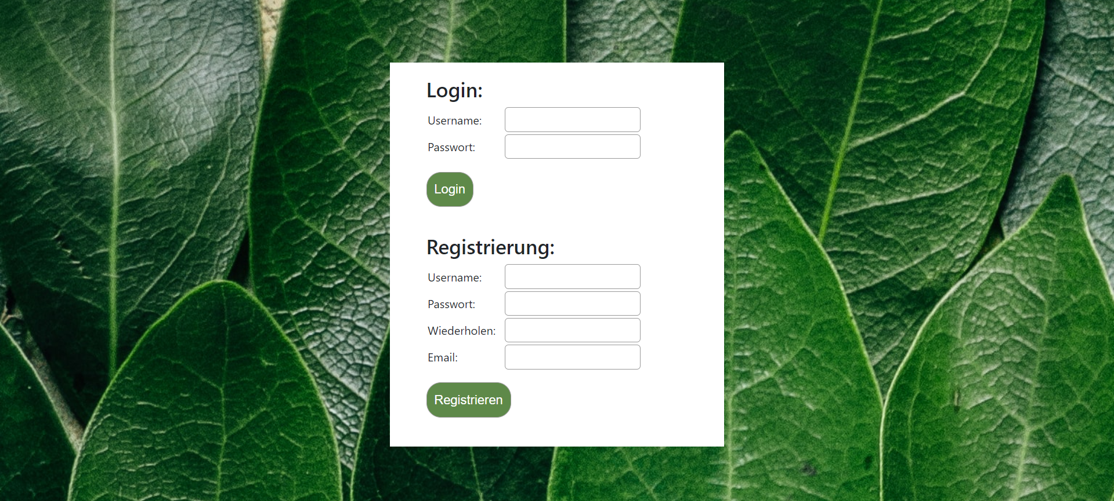

**Fehler: keine Logindaten eingegeben**

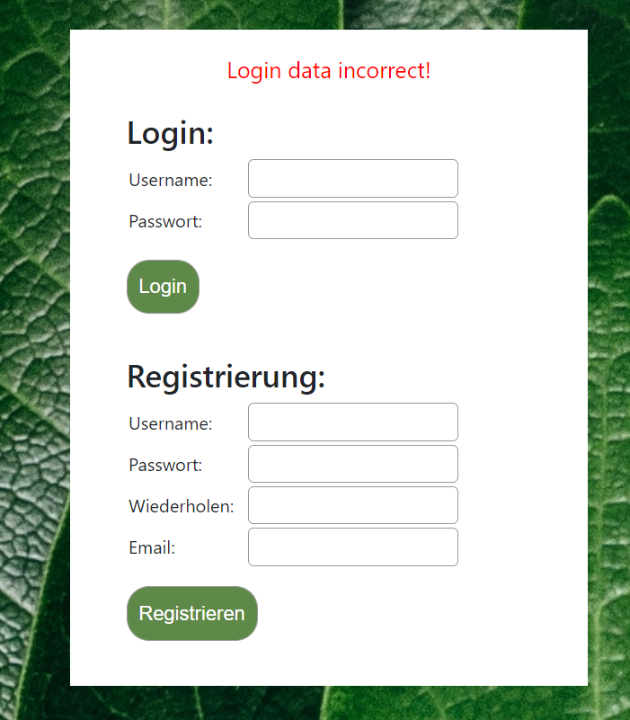

**Fehler: keine/falsche Registrierungsdaten eingegeben**

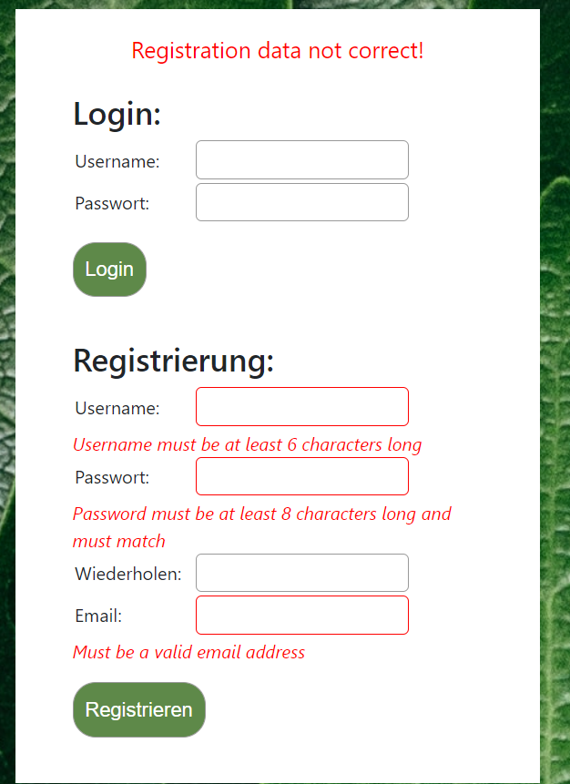

**Auch Eingaben bleiben erhalten**

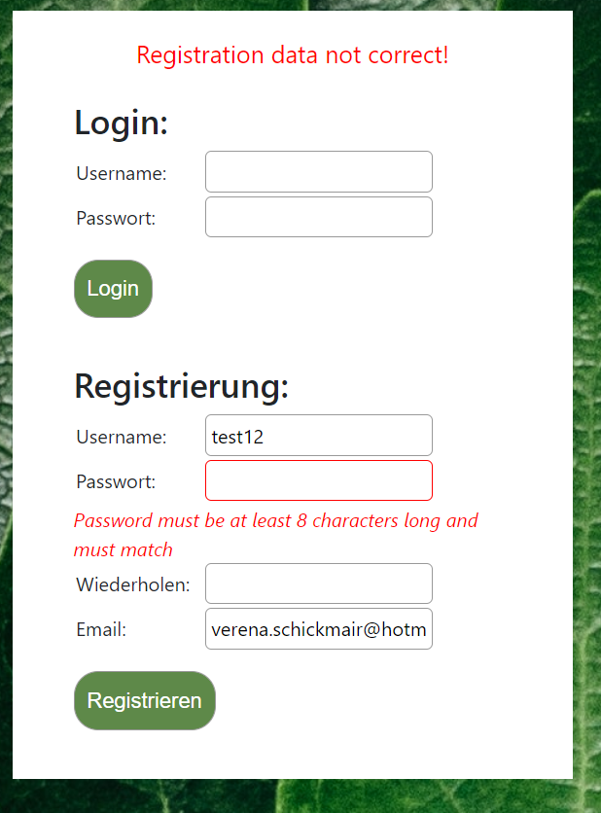

**Erfolgreiche Registrierung**

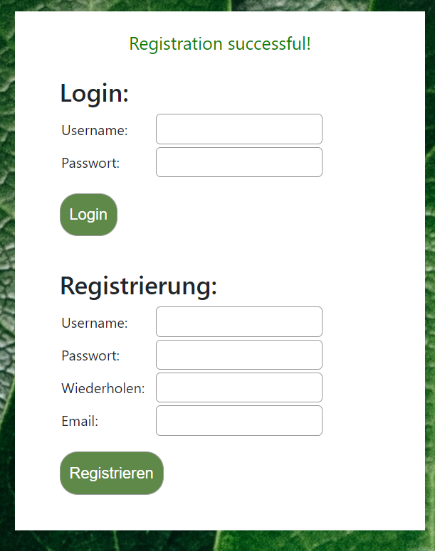

**Fehler: Registrierung -> User existiert bereits**

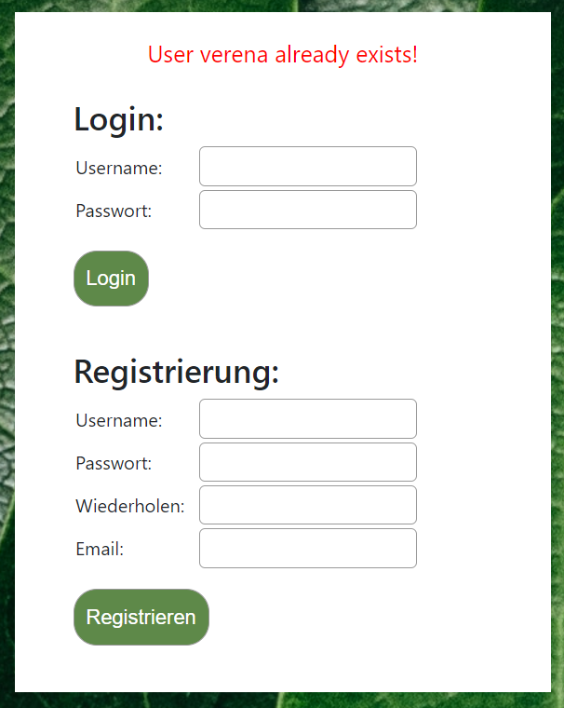

**Admin eingeloggt -> sieht alle Tasks**

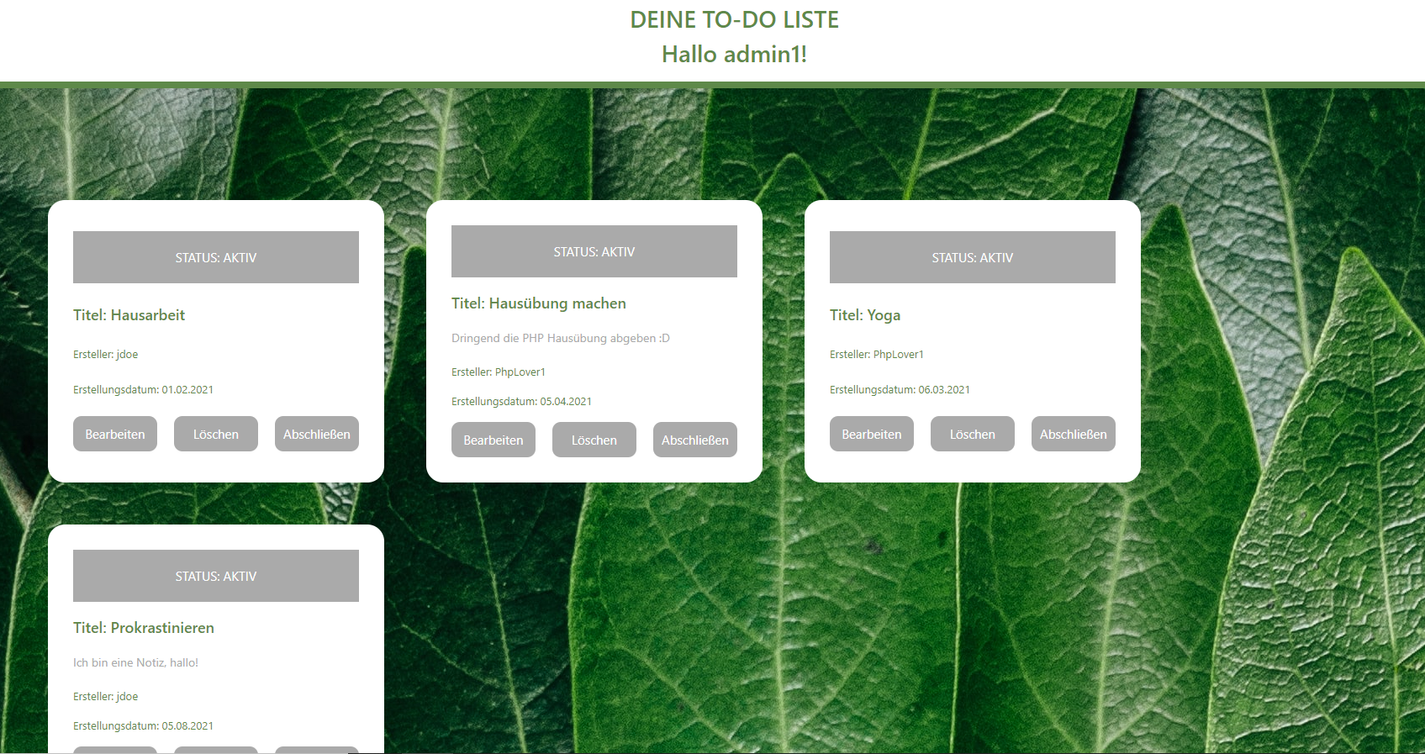

**Liste von User jdoe mit reingeladenen Daten -> nur seine Tasks sichtbar**

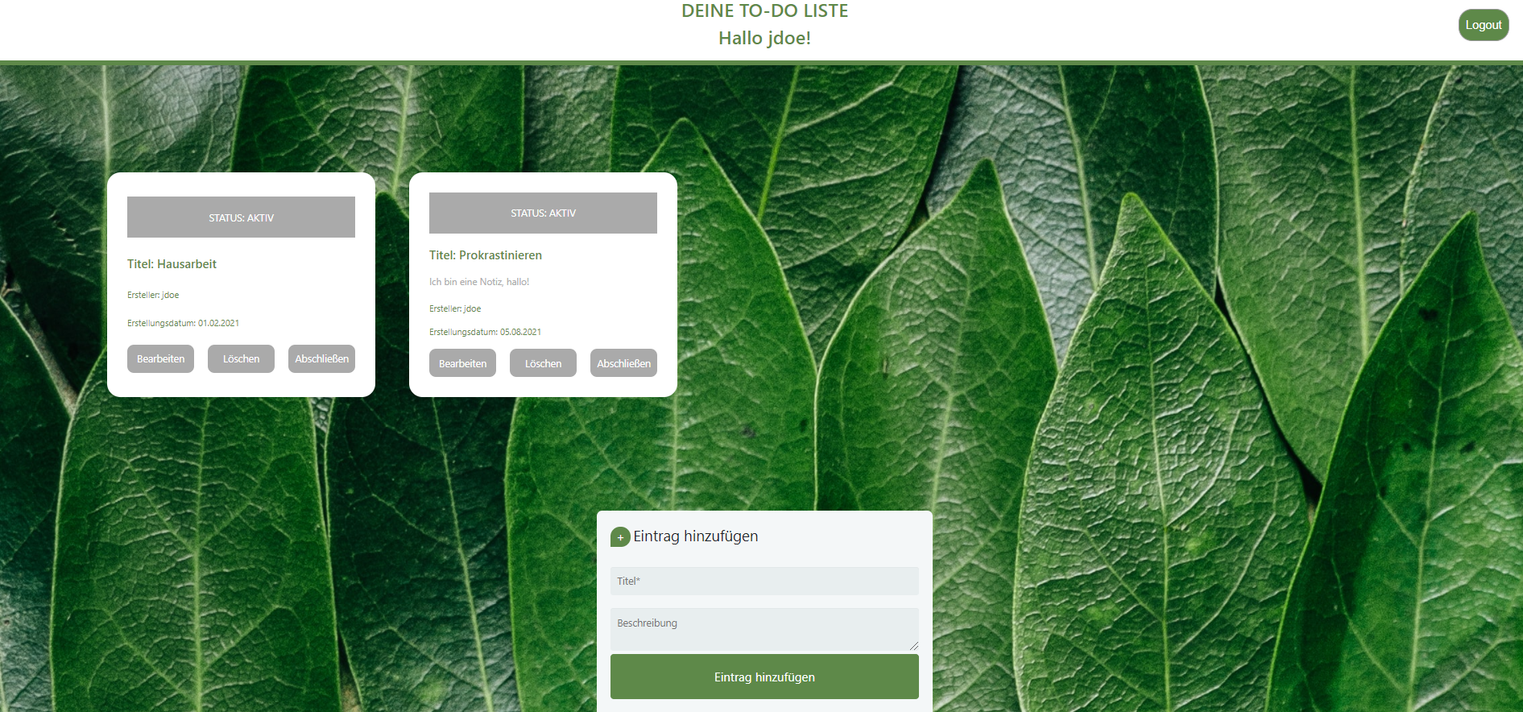

**Fehler: Eintrag hinzufügen (nur Titel verpflichtend, darum keine Fehler bei Description)**

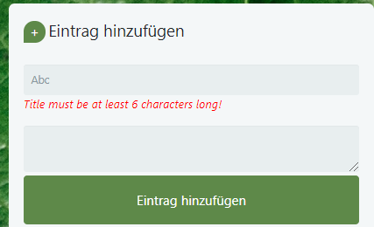

**Neuer Eintrag hinzugefügt**

